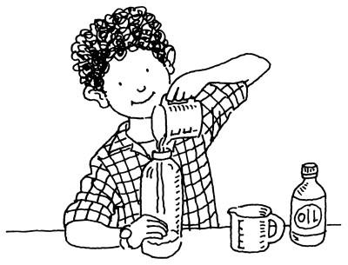
Science – Term Two
Name:
Matter- Solids, Liquids and Gases

Assessment Task: Scientific Report
What you will need to do: You will need to plan, conduct and reflect on an experiment to show how matter can change from one state to another. You will need to conduct the experiment at home and take photos or videos. You will then write your findings as a scientific report.
Your report needs to include the following information:
Hypothesis - What you hope to prove in your experiment.

List of materials - List all of the materials you need to do the experiment.
Instructions – Step by step instructions for conducting the experiment. Include everything you did, from setting it up to making observations. Someone else should be able to reproduce your experiment just by following your instructions.

Results/Observations of Experiment – While conducting your experiment, look for changes that happen throughout. Record this information as the results. Take before and after pictures to include with your report.

Conclusion: Write a conclusion that states whether your hypothesis was proved correct. Include reasons you believe your hypothesis was shown to be correct or not. State how you would do the experiment differently in the future.

Extension: Show how you would expand on the experiment, such as including different variables to test.
Labelled diagrams – Include drawings, images and/or real life photos of your experiment.

Experiment completed at home (videos and photos taken):
Draft of Science report due date:
Final Science report due date:

Experiment planning sheet
Name and Partner’s Name:
Experiment name:

What states you are changing (eg/ solid → liquid):

Materials (what you need):

Instructions (what to do):

** Remember your experiment needs to be completed at home by Wednesday 16th March and you need to have videos and photos evidence of your experiment. GOOD LUCK!

